Final Project Report — Programming Fundamentals

University Name: FAST - NUCES
Department: Department of Artificial Intelligence
Course: Programming Fundamentals - Lab
Project Title: University Management System
Submitted By: Syed Taimoor Ali - 25K-0096
Submitted To: Miss Izzah Salam
Semester: Fall 2025
Date: 25th November 2025

Abstract
The University Management System is a console-based C program designed to make managing academic information easier and more organized. Instead of relying on manual registers or scattered files, this system stores everything in one place student records, teacher details, course enrollments, attendance, exam results, fee status, retake requests, transcripts, and even course feedback. It uses structures, functions, arrays, and file handling to save data permanently, allowing the system to run smoothly and reliably. By automating tasks that were previously done by hand, the project reduces errors, saves time, and makes information easier to access whenever needed. Overall, it showcases the essential concepts of the C language while demonstrating how they can be used to build a complete, practical, and efficient academic management system.

1. Introduction
Managing university data manually whether it’s course details, student records, attendance, or exam results can be slow, inconsistent, and highly prone to mistakes. To handle these academic tasks efficiently, a centralized digital system has become essential. This project introduces a Console Based University Management System developed in the C programming language. Its purpose is to provide an organized and automated way to store and access student information, academic history, and financial records through a simple, menu-driven interface. By using file handling, the system ensures that all data remains safely stored even after the program closes. Throughout its development, the project reinforces key programming concepts such as modular design, data structures, loops, conditionals, arrays, and file handling making it both practical and educational.

2. Objectives
- To store and manage complete student records.
- To maintain course enrollments and teacher assignments.
- To track and update attendance for each student.
- To store exam results, calculate performance, and generate transcripts.
- To manage student fee information and dues.
- To handle exam retake requests efficiently.
- To collect course feedback from students.
- To provide a menu-based interface that is easy to use.
- To apply file handling for secure, permanent storage of academic data.

3. System Design

System Overview
The University Management System consists of multiple interconnected modules:
- Student Information Module
- Course Management Module
- Teacher Records Module
- Attendance Module
- Exam Result Module
- Exam Retake Request System
- Fee/Finance Module
- Transcript Generation Module
- Course Feedback Module
The user interacts with a menu, selects the desired operation, and performs additions, updates, searches, or report generation.
Program Flow:
Start → Display Menu → Select Module → Perform Operation → Save/Load Using Files → Return to Menu → Exit

Algorithm
- Start the program
- Display the main menu
- Ask the user to select a module
- Perform the selected action:
- Add, view, update, or delete records
- Mark attendance
- Enter exam results
- Submit retake request
- Generate transcript
- Use file handling to save or load data
- Return to the menu
- Exit the program

Input & Output
Input Includes:
- Student personal details
- Teacher names and courses
- Course information
- Attendance entries
- Exam marks
- Fee details
- Retake requests
- Feedback text
Output Includes:
- Student list
- Course records
- Attendance reports
- Exam results
- Fee status
- Approved or rejected retake requests
- Full academic transcript

4. Implementation
Language: C
IDE/Compiler: Visual Studio Code, GCC
Data Storage: Binary files
Programming Concepts Used:
- Structures
- Arrays
- File handling
- Functions
- Conditional statements
- Loops
- Switch-based menu system

Key Features
- Add/update/delete student information
- Store teacher details and courses handled
- Manage course enrollments and schedules
- Mark attendance for each student
- Enter exam marks and calculate results
- Submit and view exam retake requests
- Generate auto-formatted transcript
- Store and display fee history and dues status
- Collect course feedback
- Permanent storage using external files

Code Snippet
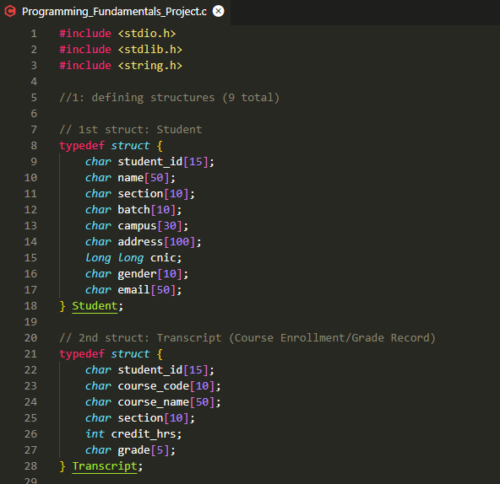
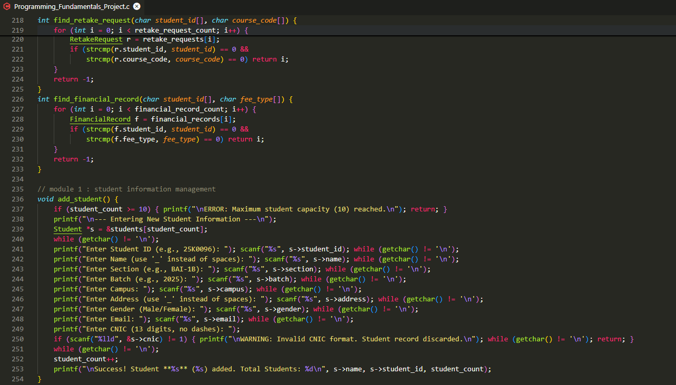

Sample Output
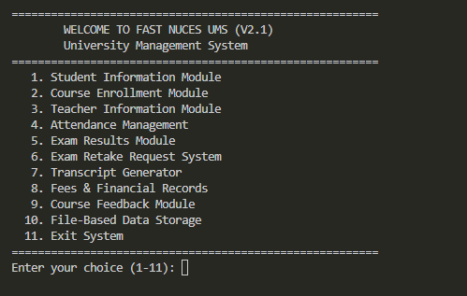

5. Testing & Results
Test No | Module | Input | Expected Output | Status
1 | Module 1 (Student) | UPDATE: Student ID: 25K0101, Change Campus to Peshawar | Student 25K0101 Campus is updated to Peshawar. | ✅
2 | Module 2 (Enrollment) | CALCULATE GRADE: Student: 25K0096, Course: CL1000 (Weighted Score: 93.00%) | Final Grade for CL1000: A+ | ✅
3 | Module 3 (Teacher) | DELETE: Teacher Name: Miss_Alishba | Teacher Miss_Alishba record is deleted. teacher_count decrements. | ✅
4 | Module 4 (Attendance) | REPORT: Course Code: CL1000 (Student 25K0096: 1 Present, 1 Absent, 2 Total) | Student 25K0096 Attendance: 50.00% | ✅
5 | Module 5 (Exam Results) | UPDATE MARKS: Student: 25K0105, Course: CL1000, Assessment: Midterm, New Marks: 45 (Total 50) | Obtained Marks for Midterm updated to 45. | ✅
6 | Module 5 (Exam Results) | SUMMARY: Course Code: CL1000, Assessment: Final | Correct Class Average (e.g., 81.00) and Min/Max scores displayed. | ✅
7 | Module 6 (Retake) | APPROVE: Student: 25K0105, Course: CL1000 | Request Status updated from Pending to Approved. | ✅
8 | Module 7 (Transcript) | GENERATE: Student ID: 25K0096 | Displays Student Info and CL1000 with the calculated Grade A+ (from Test 2). | ✅
9 | Module 8 (Financial) | DUES CHECK: Student ID: 25K0096 (Dues: 35000) | Total Amount Owed: 35000 | ✅
10 | Module 9 (Feedback) | REPORT: Course Code: CL1000 (2 submissions, Total Teaching Rating: 8) | Average Teaching Quality: 4.00 | ✅
11 | Module 10 (Storage) | SAVE ALL DATA (Manually exits) | Program loads updated data (e.g., Student 25K0101's Campus, Approved Retake Request). | ✅

6. Conclusion, Limitations & References

Conclusion
The University Management System offers a complete, file based digital solution for handling academic information in an organized way. It takes care of tasks like storing student records, tracking attendance, recording exam results, processing retake requests, managing fee details, and generating transcripts all without the need for manual paperwork. By using core concepts of C programming, the project brings together multiple modules to form a practical and efficient system that works much like a real academic management platform.

Limitations
- No graphical interface fully console based
- No login system for different user roles
- No advanced database (only file handling)
- Data must be manually validated by the user

Future Enhancements
- Adding login roles for Admin, Teacher, Student
- Upgrading to GUI or Web-based system
- Integrating SQL database
- Adding analytics dashboards
- Automating email/SMS notifications

References
- C How to Program by Harvey Deitel and Paul Deitel
- programiz.com
- Classroom lectures & course notes
- https://flexstudent.nu.edu.pk/Login
- https://www.youtube.com/@BroCodez

